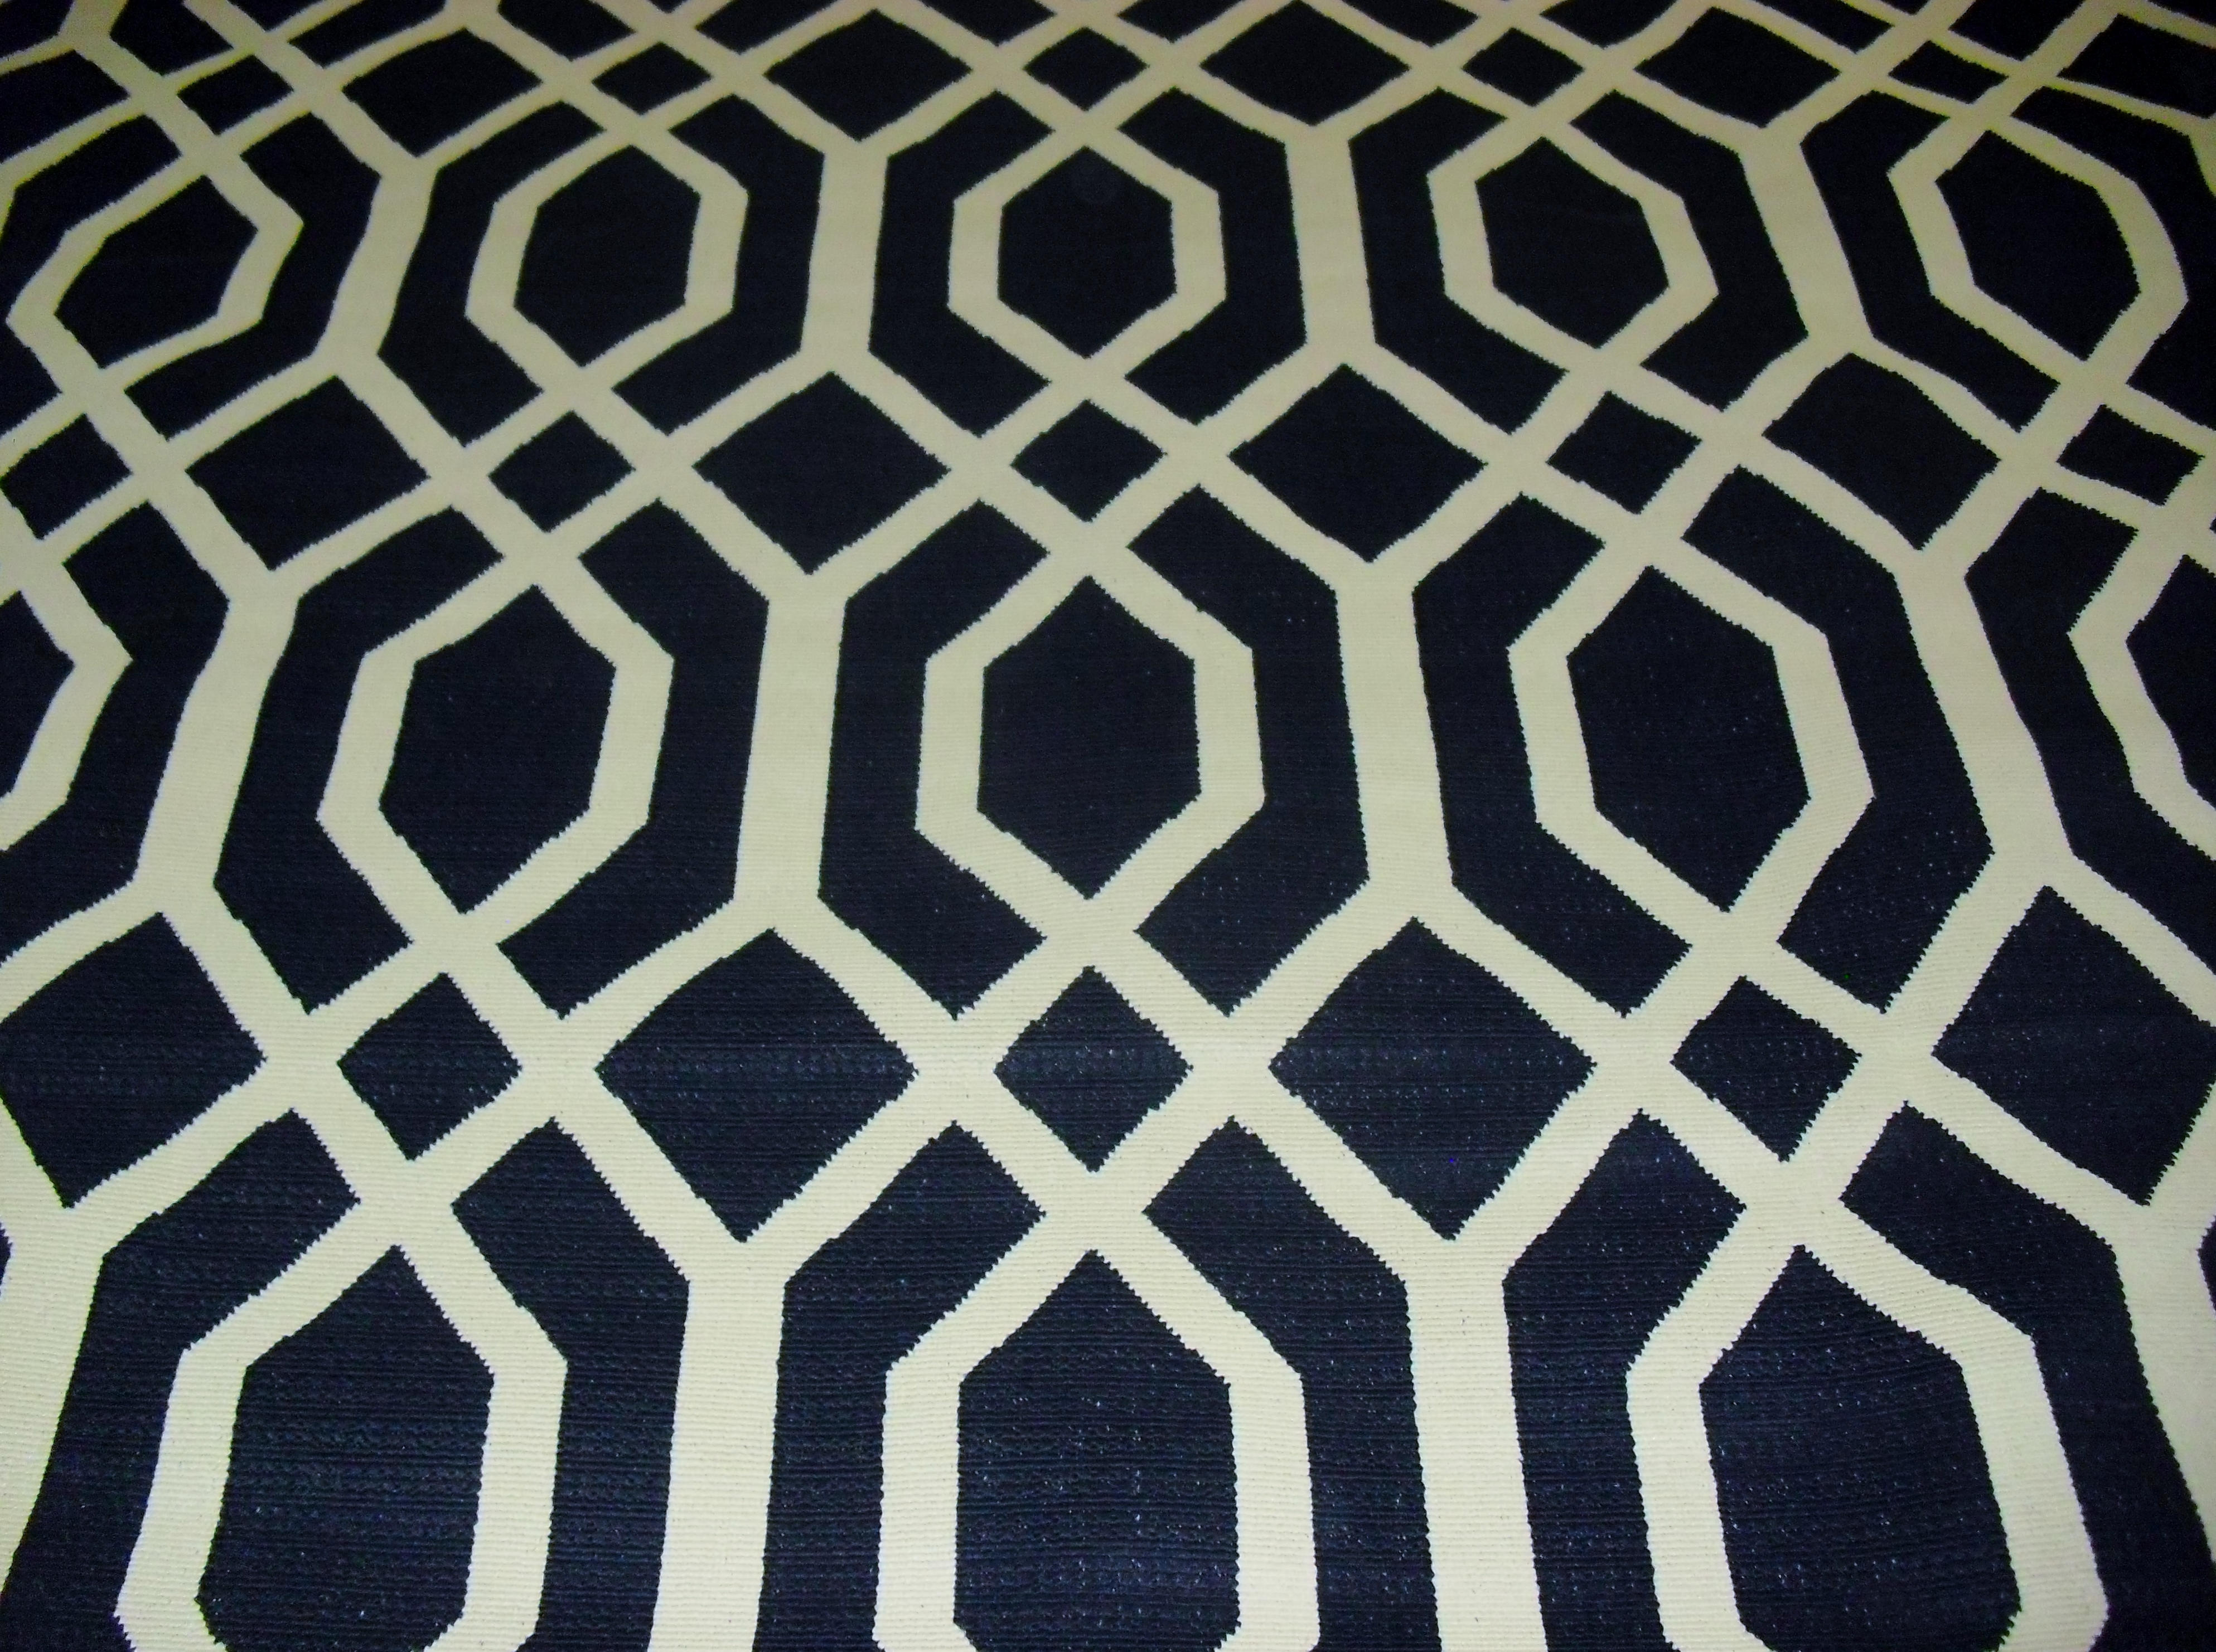
TITLE: HAMPTON BAY "NAVY LATTICE" BLACK & BROWN 5' 3" X 7' 4" INDOOR OUTDOOR AREA RUG
DESCRIPTION:
HAMPTON BAY "NAVY LATTICE" BLACK & BROWN 5' 3" X 7' 4" INDOOR OUTDOOR AREA RUG
100% Polypropylene
Whether you are looking to dress up your outdoor patio, sun room or any indoor/outdoor living space, this rug is the ideal solution. Featuring beautiful beige and black colors, this indoor/outdoor area rug is easy to clean and maintain. This rug is beautifully woven to complement a host of decorating styles.

PRICE $139.99

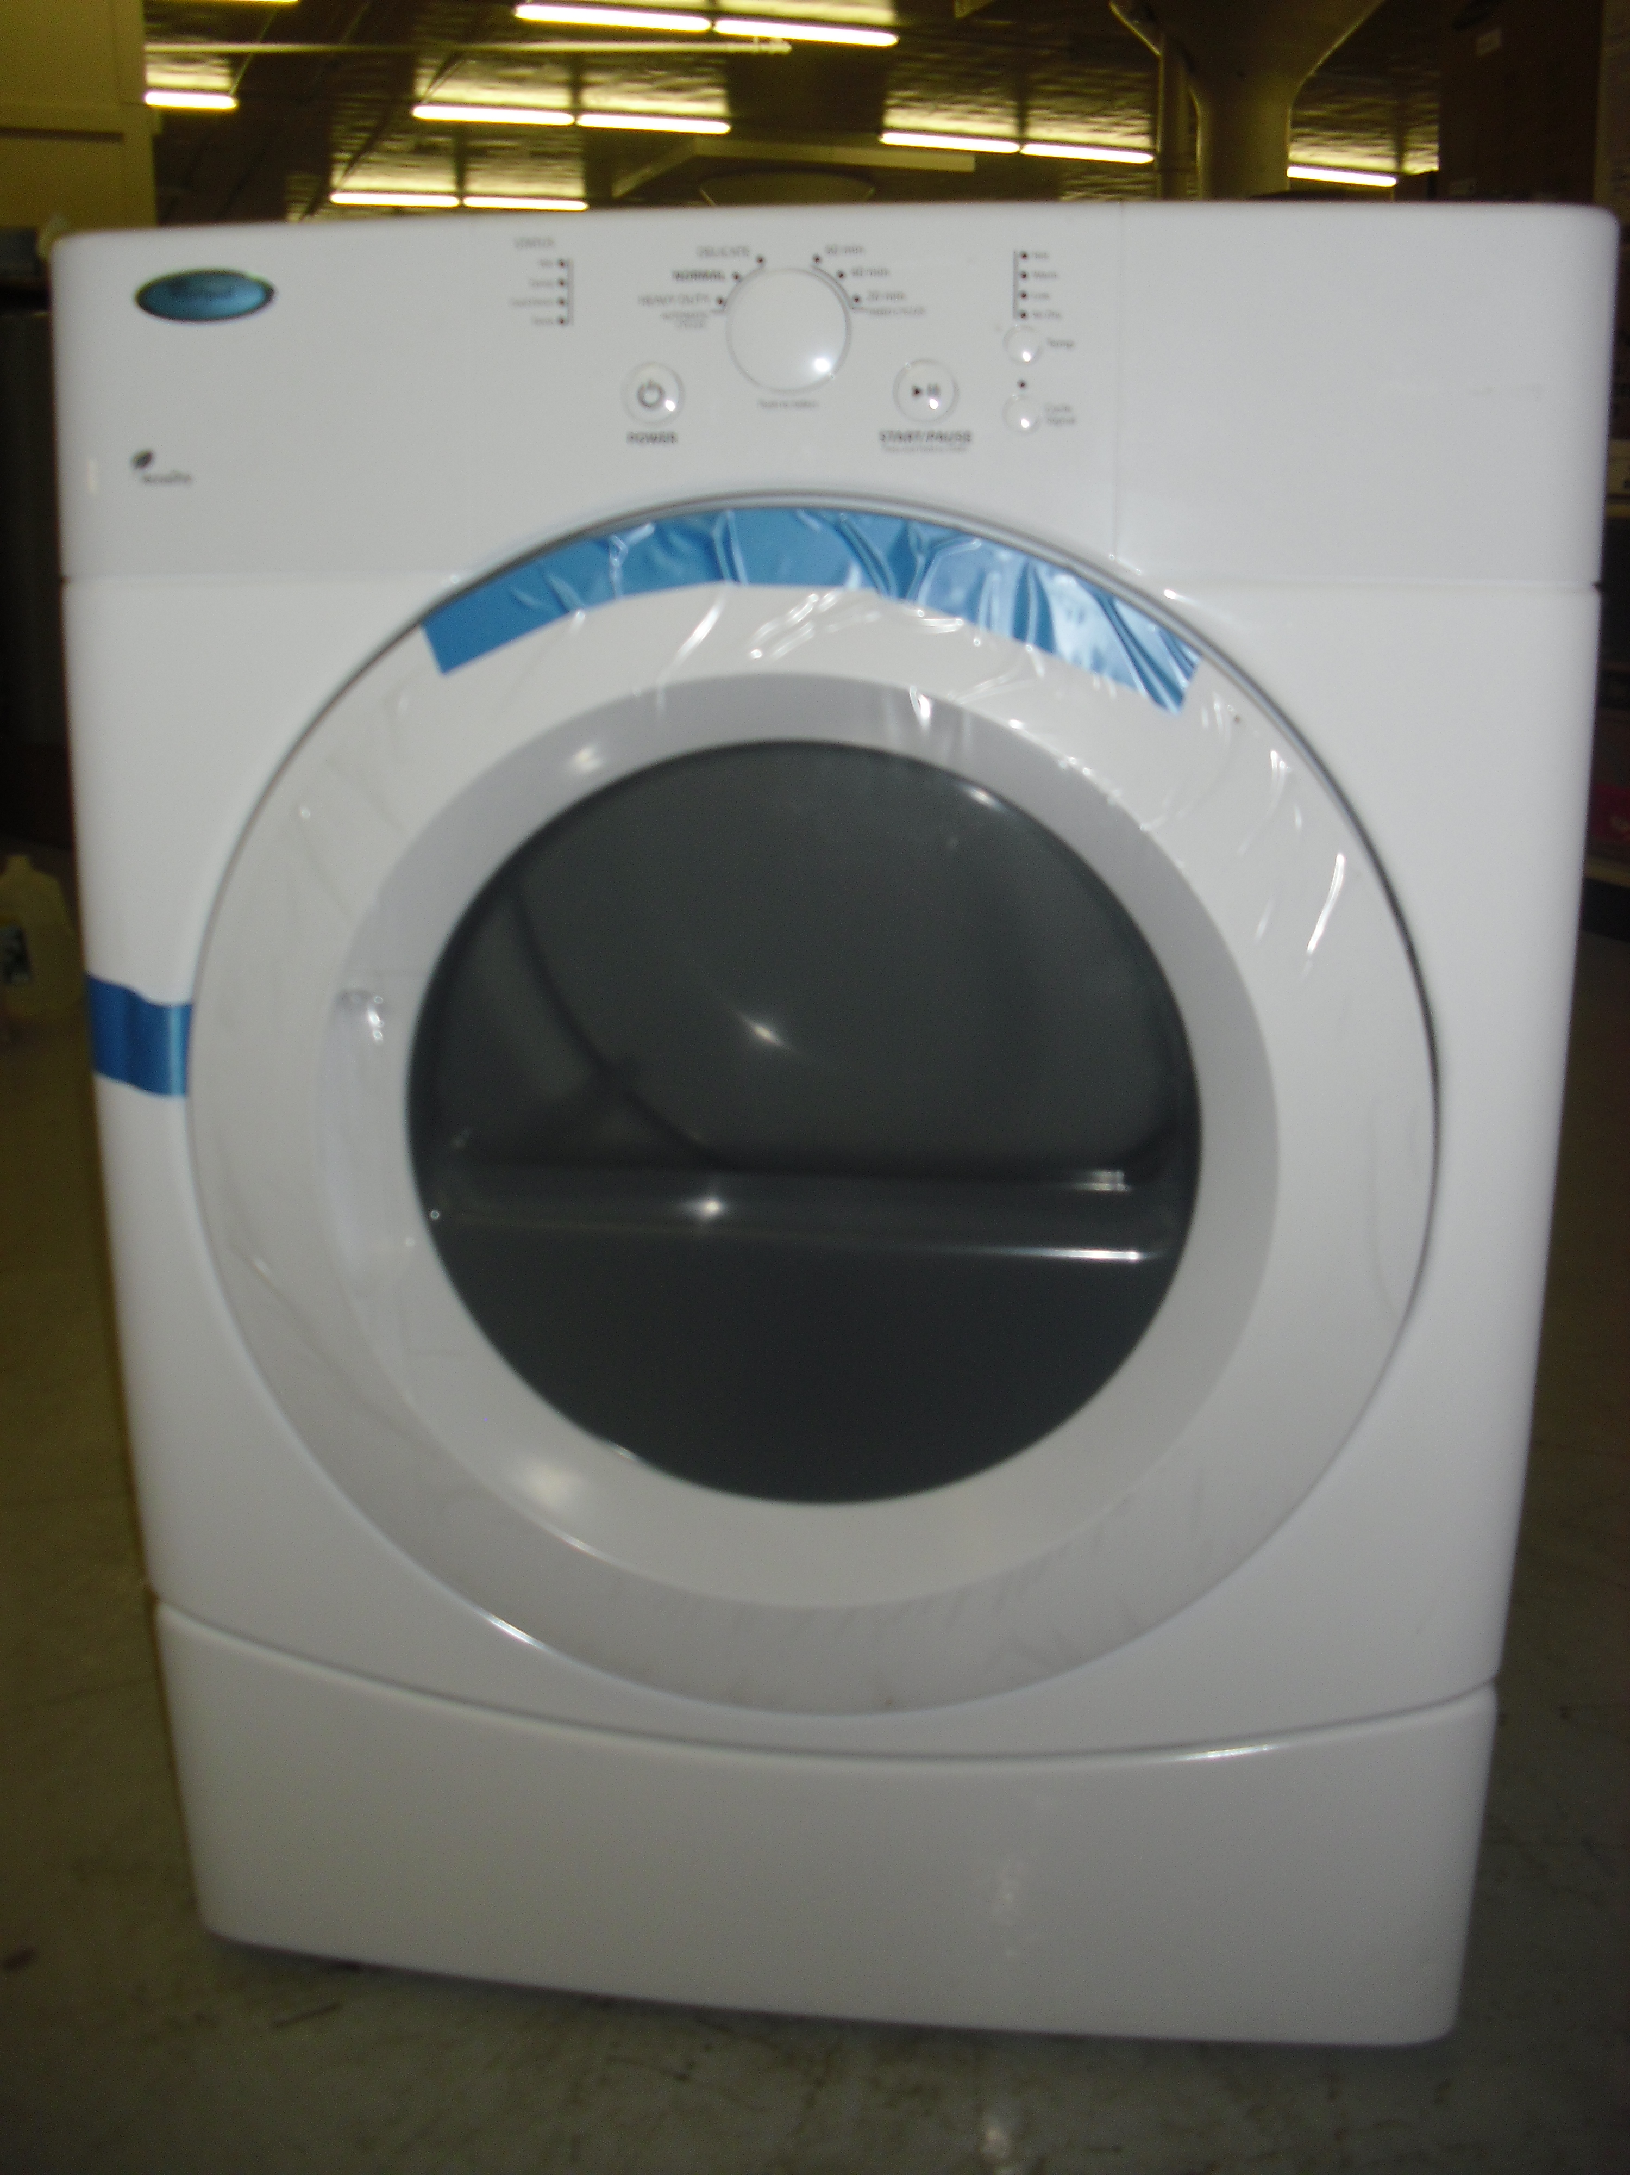

TITLE: Whirlpool WED9050XW White Electric Dryer
DESCRIPTION:
Whirlpool WED9050XW White Electric Dryer
6.7 Cu. Ft. Capacity/ AccelerCare Drying System/ Quiet Dry Noise
Reduction System/ Adjustable End-Of-Cycle Signal/ Interior Drum
Light/ AccuDry Sensor/ 3 Automatic Cycles/ 4 Temperature
Settings/ 4-Way Venting/ White Finish
PRICE: $499.99

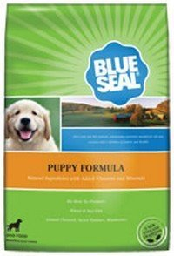
TITLE: Kent Nutrition Blue Seal Puppy Formula 8 Lbs.
DESCRIPTION: Kent Nutrition Blue Seal Puppy Formula 8 Lbs. Ntural Ingredients with Added Vitamins and Minerals, No Meat By Products, Wheat & Soy Free, Ground Flaxseed, Sweet Potatoes, Blueberries
WE ARE AN AUTHORIZED BLUE SEAL SELLER.
BLUE SEAL PRODUCTS ARE PASSIONATE ABOUT BRINGING YOU WHOLESOME PRODUCTS TO HELP YOUR ANIMALS GROW STRONG, STAY HEALTHY, AND LIVE HAPPY.
THE PEOPLE OF BLUE SEAL FEEDS STRIVE TO ENRICH YOUR LIFE AND EXCEED YOUR EXPECTATIONS BY PROVIDING YOUR PETS WITH HIGH QUALITY NUTRITION YOU CAN TRUST.
The nutrient-dense formula contains the appropriate protein and fat levels to help puppies grow into energetic and healthy adults. Contains omega-3 fatty acids to help support brain development.
PRICE: $24.99
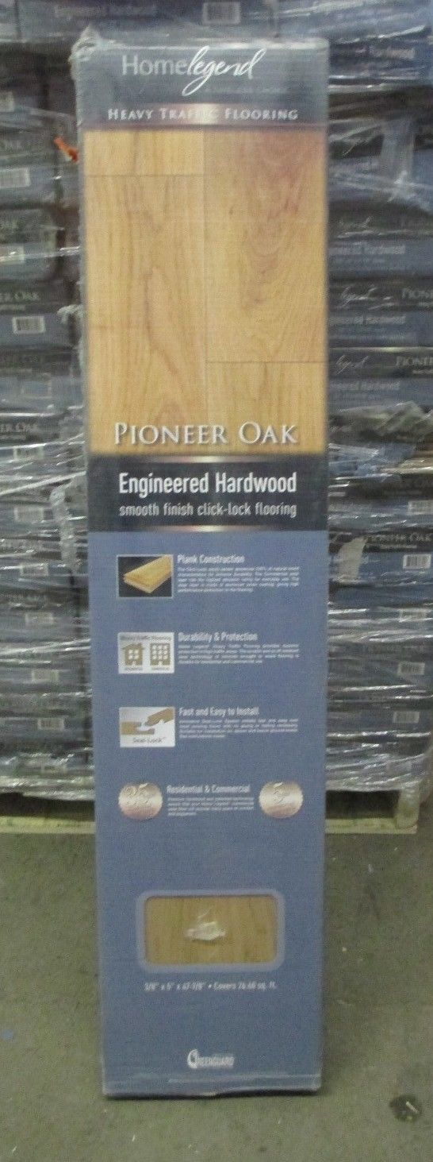
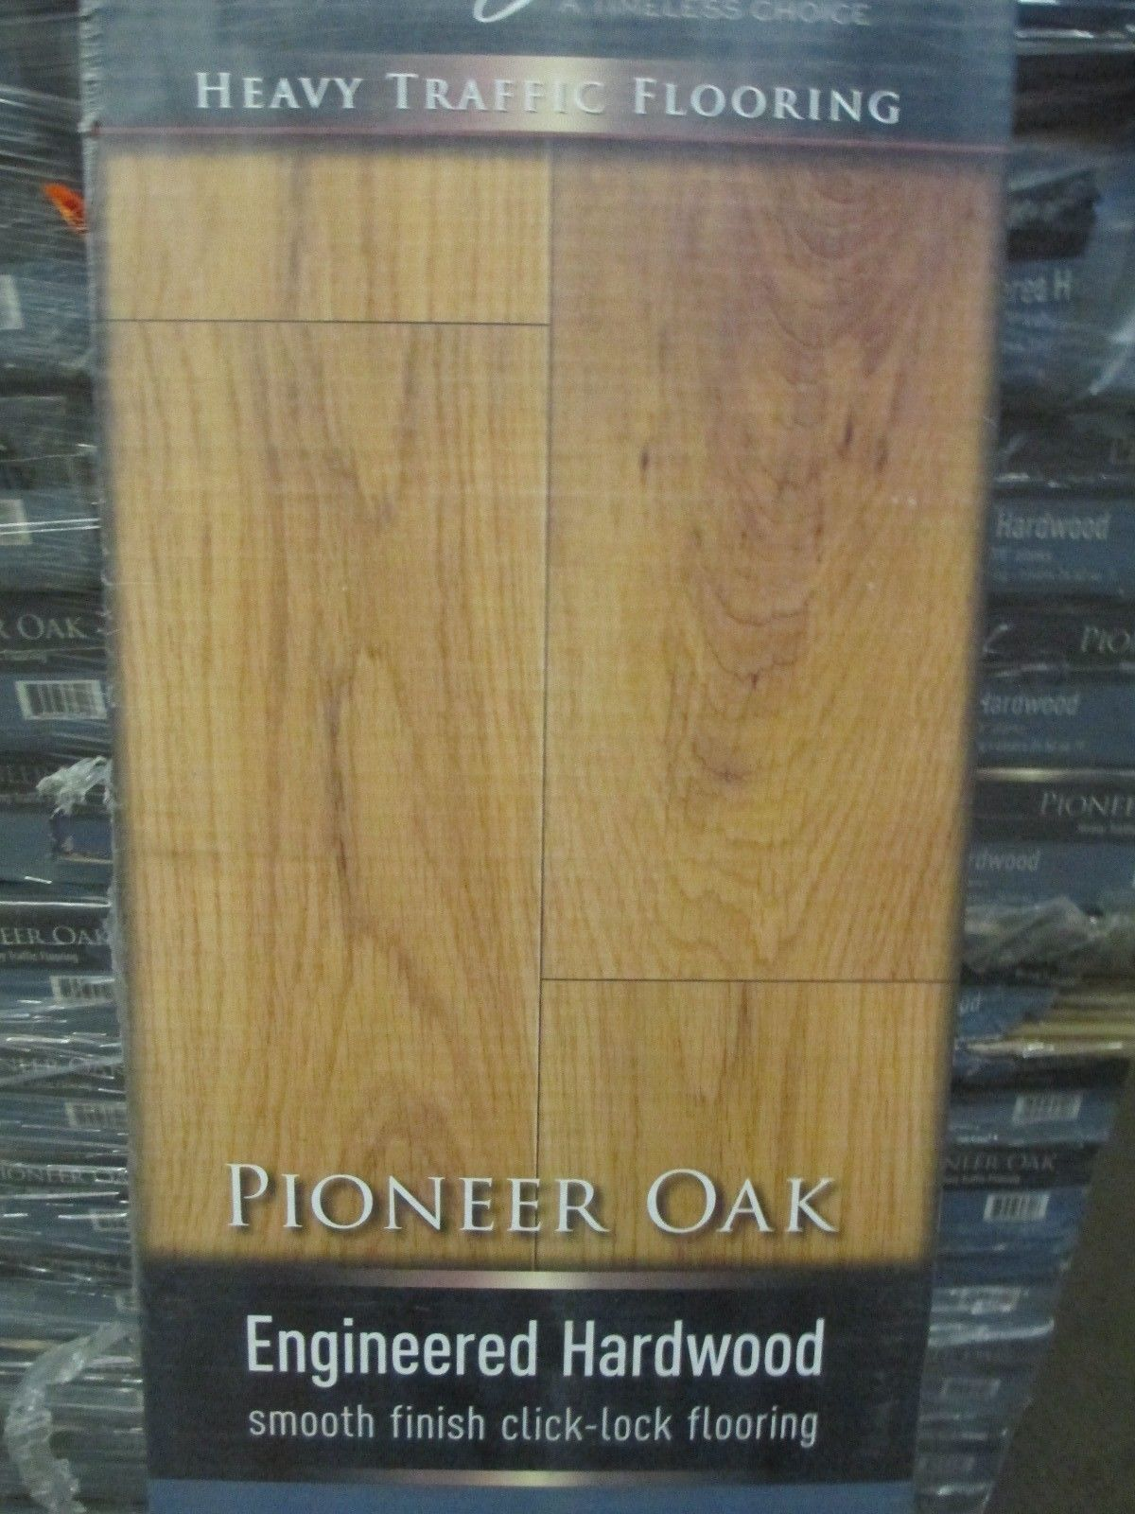
TITLE: Home Legend Heavy Duty Pioneer Oak Flooring 3/8" T x 5" W x 47-7/8" L HL141H
DESCRIPTION:

Home Legend Heavy Duty Pioneer Oak Flooring 3/8" T x 5" W x 47-7/8" L HL141H

Home Legend 3/8 in. High Density Fiberboard (HDF) Click Lock Hardwood planks have a 7 layer aluminum oxide finish, providing everyday wear and tear protection. This product has achieved Greenguard Indoor Air Quality certification and has been tested for more than 10,000 volatile organic compounds, including formaldehyde, to meet these standards. The glueless installation is easy and economical; above grade, on grade and below grade. The beauty of hardwood floors add style and timeless appeal to contemporary and traditional homes.

PRICE: $119.99

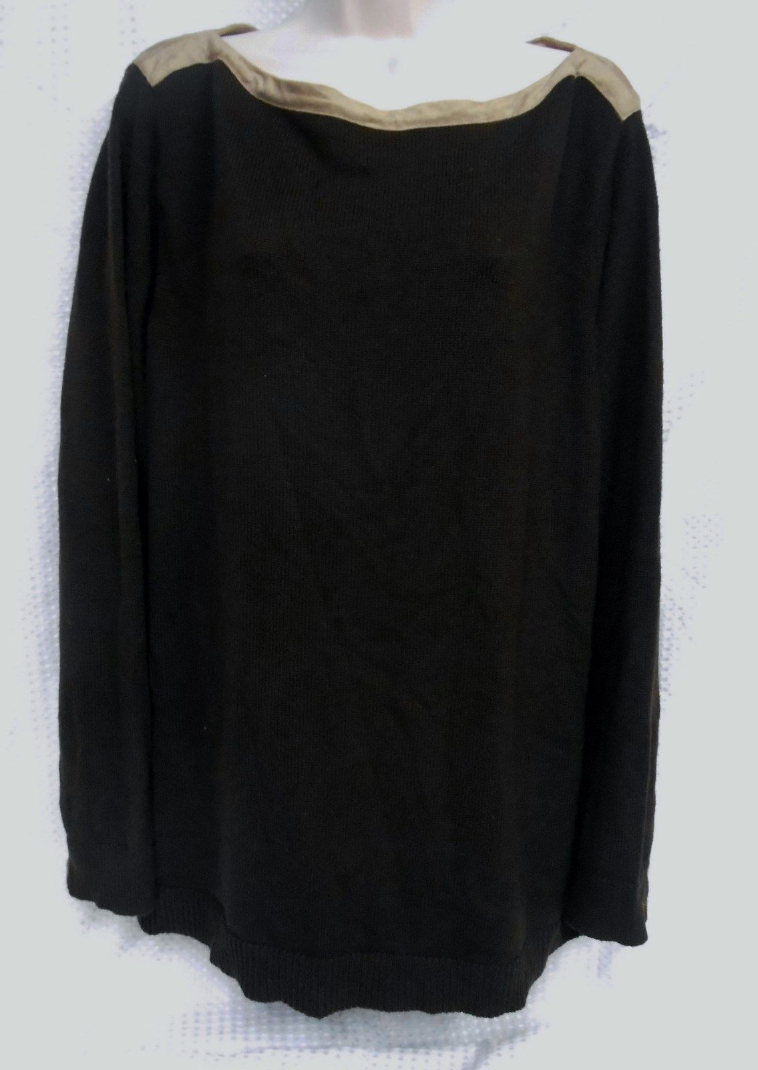
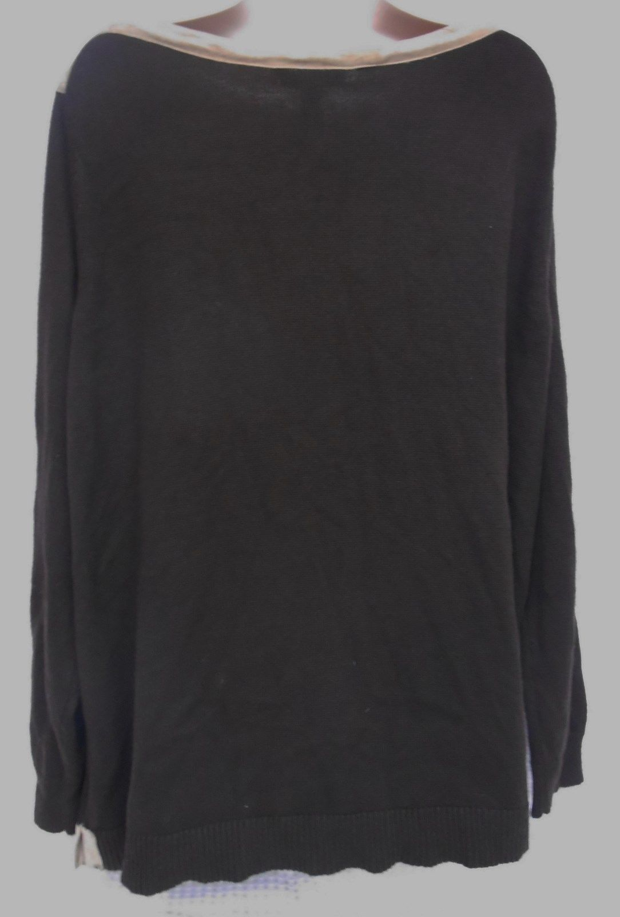
TITLE: RALPH LAUREN RL LONG SLEEVE BROWN W/ TAN TRIM BOAT NECK SWEATER 2X
DESCRIPTION:
RALPH LAUREN RL LONG SLEEVE BROWN W/ TAN TRIM BOAT NECK SWEATER 2X

A VERY STYLISH ADDITION FOR THE OFFICE OR A SKI WEEKEND.
TREAT YOURSELF!
THE TRIM IS MAN MADE MATERIALS, NOT LEATHER,
THAT IS FEATURED ON THE NECK AND SQUARES ACCENTING THE SIDES.

THE MEASUREMENTS BELOW WERE TAKEN WITH THE SWEATER LAYING FLAT:
ARMPIT TO ARMPIT 51"
BACK 26"
FRONT 26"
ARM LENGTH 25"
FABRIC CONTENTS:
30% NYLON
25%VISCOSE
25% WOOL
20% POLYESTER
PRICE: $49.99

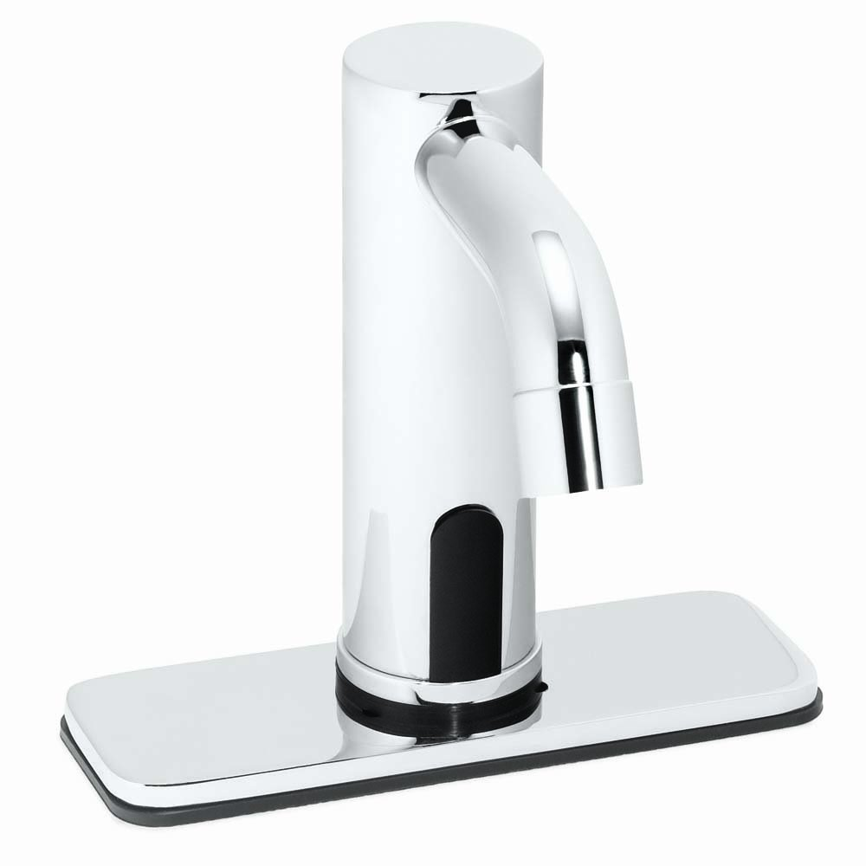
TITLE: Speakman S-9310 Sensorflo Battery Powered Sensor Faucet with 4-Inch Deck Plate
DESCRIPTION:
Speakman Sensorflo Tubular spout battery operated faucets provide facilities with ultimate reliability and easy maintenance. Perfect for hotels, private washrooms and other public commercial lavatories, the S-9310 lavatory faucet features a 4-Inch deck plate with all brass body and spout. with all electronics and batteries housed above the counter, maintenance of the S-9310 is simple and can be performed in minimal time. The faucet is equipped with a solenoid with a built-in filter and a 60-second time out feature to prevent floods. The S-9310 uses two (2) 3-volt lithium batteries and features a low battery warning light which indicates when 10-Percent life remains. The Speakman Sensorflo faucet line is certified to meet ASME A112.18.1/CSA B125.1.

PRICE: $299.99

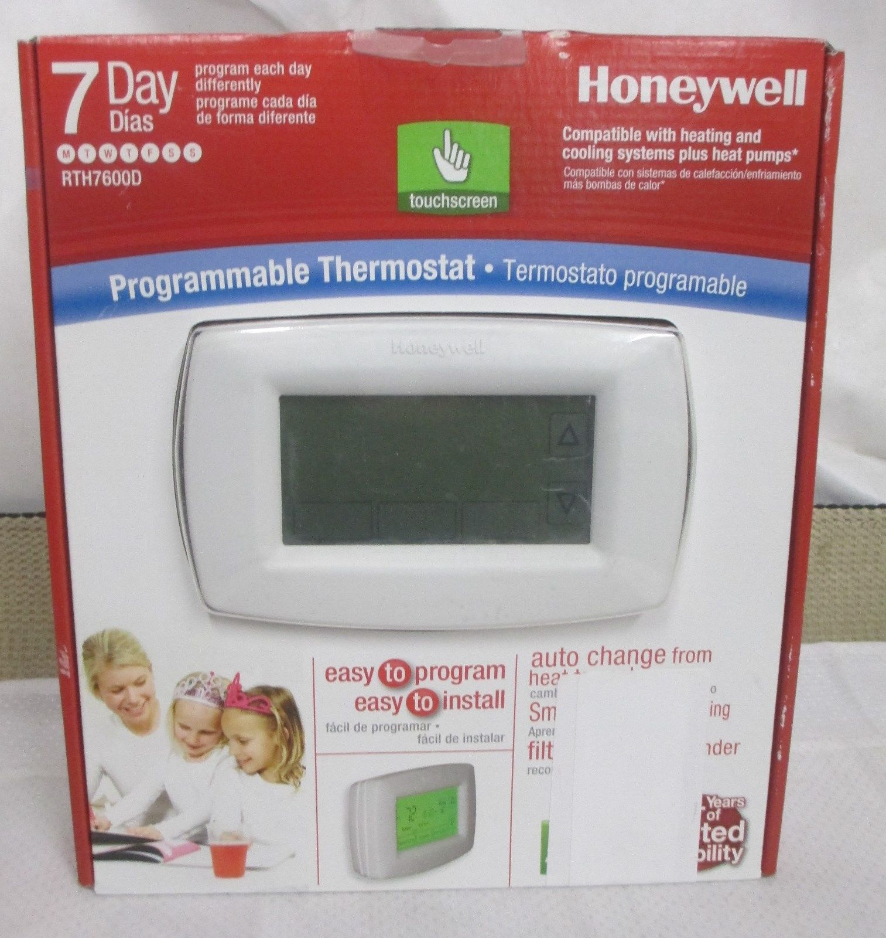
TITLE: Honeywell RTH7600D 7-Day Programmable Touchscreen Thermostat
DESCRIPTION:
Daylight savings time ready (optional)
Battery-powered or option to hard-wire
Extra large backlit touch-screen display
Permanent day and time backup
Selectable temperature range stops
PRICE: $39.99
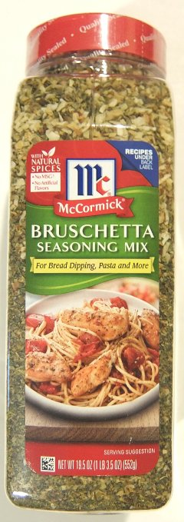
TITLE: McCormick Bruschetta Seasoning Mix (19.5 ounce shaker)
DESCRIPTION:
With natural spices
- No MSG or artificial flavors
- For bread dipping, pasta and more
- Delicious blend of onion, garlic, oregano and other spices
- 19.5 ounce shaker
PRICE: $18.99
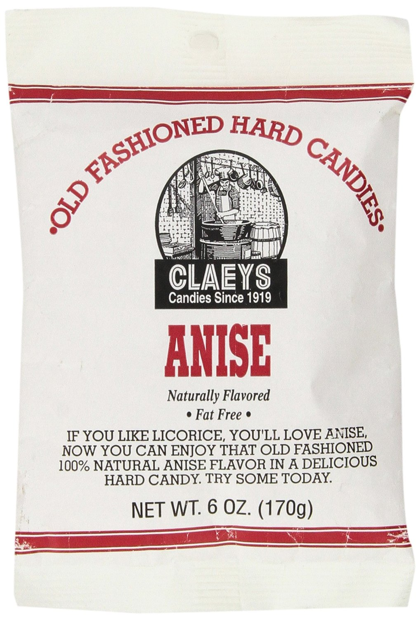
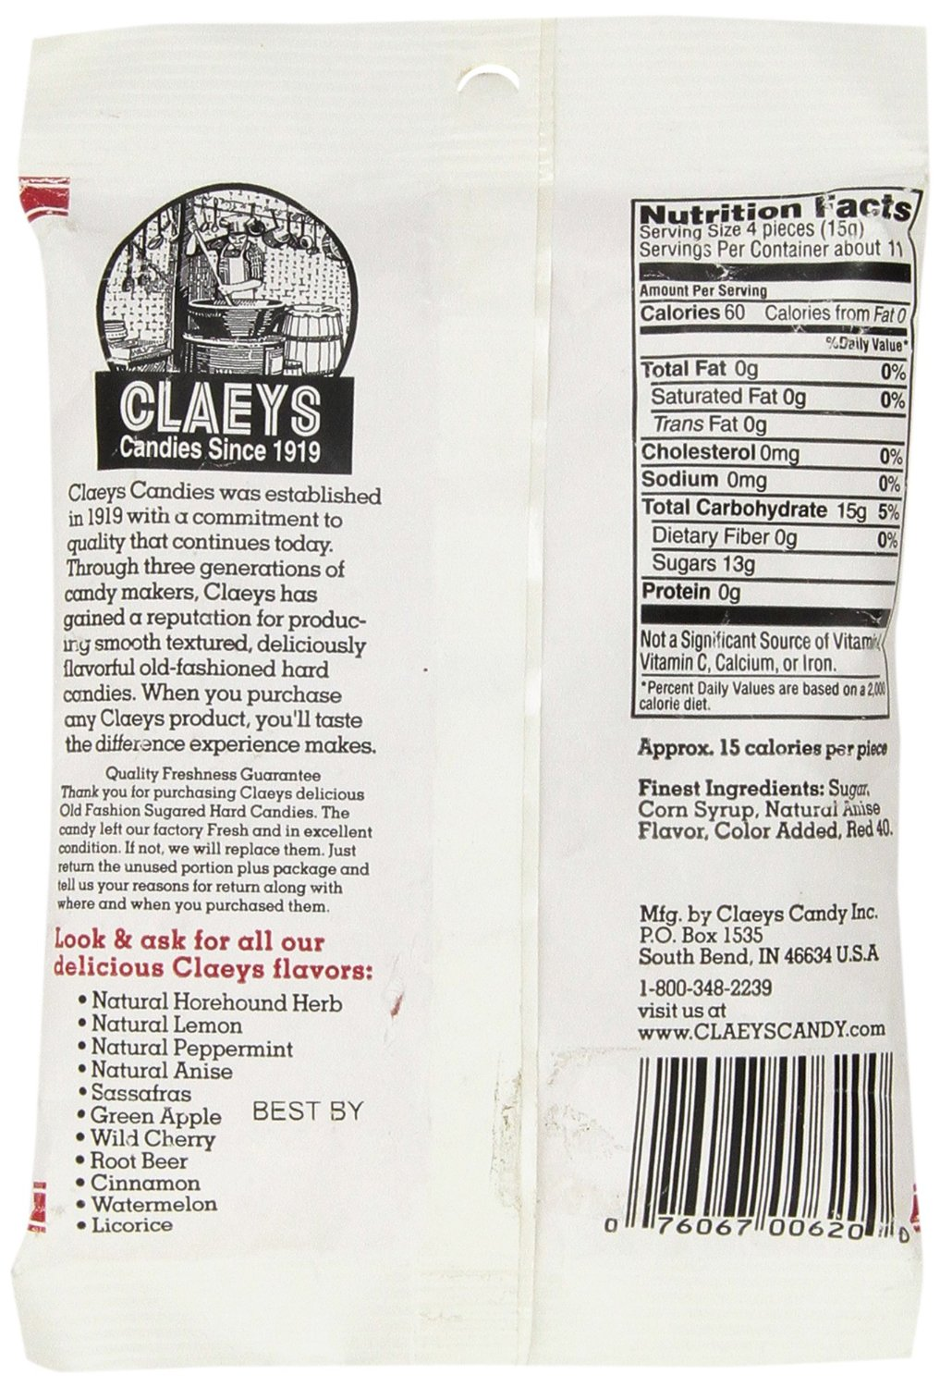
TITLE: Claey's Natural Anise Drops – 6oz.
DESCRIPTION: There is nothing quite like the sweet and aromatic taste of Claeys Candy anise drops. These candies have a licorice like flavor you won't be able to get enough of once you try them. Get ready to taste the history in each bag.

INGREDIENTS: sugar, corn syrup, natural anise flavor, Color Added, red 40

PRICE: $3.99

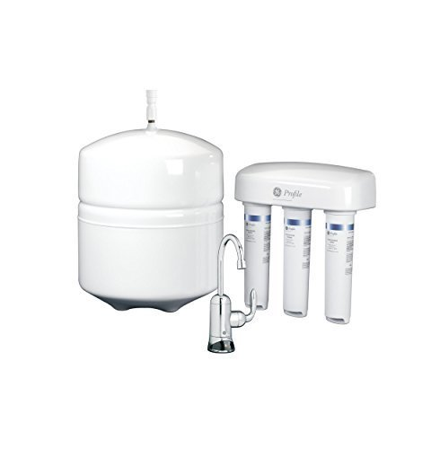
TITLE: General Electric PXRQ15RBL Reverse Osmosis Premium Water Filtration System by General Electric

DESCRIPTION: remium filtration process. Extra-large 8.46 gallon capacity per day. Chrome faucet, pre-and-post filters (FQROPF), membrane (FQROMF), storage tank, filter reminder light and full installation kit included.
Long-reach chrome faucet, Pre/post filter life 900 gallons, Max. Hardness 10 Grains @ 6.9 pH
Water Inlet Valve 1/2 in. & 3/8 in. NPT ball valve adaptor, NSF particulate reduction Class III
System mounting orientation horizontal or vertical, Faucet Monitor Power Requirement 1 - CR2032 Lithium 3V (Included), Copper Reduction 97.5% Cysts Reduction 99.99% Lead Reduction 97.6% Sodium Reduction 91.6% TDS Reduction 91.6% Turbidity Reduction 99.9%

PRICE: $399.99

